PROJECT 03-07

**Spatial** **Filtering**

Write program to perform spatial filtering of an image *“*Fig_test_pattern_blurring_orig.tif*”*. Change

square average

the size of the spatial mask at 3 x 3, 5 x 5, 9 x 9, 15 x 15, 35 x 35 and compare your results with the textbook

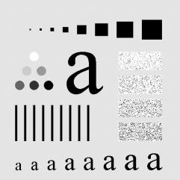 .

PROJECT 03-08

**Local** **histogram** **processing**

(a) Implement the local histogram equalization on image “embedded_square_noisy” using

neighborhood of size 3 × 3. Note that different from the spatial filtering, you can just replace the original 3 × 3 subimage by the histogram equalized values and move 3 pixels for each step.

(b) Compare the result with the global histogram equalization.



PROJECT 03-09

**Averaging** **filter** **and** **Median** **Filter**

The following image is corrupted by salt-and-papper noise.

|  |  |  |
| --- | --- | --- |
| 0 | -1 | 0 |
| -1 | 5 | -1 |
| 0 | -1 | 0 |

(a) Implement 3 ×3 averaging filter on image “ckt_board_saltpep” .

(b) Implement 3 ×3 median filter on image “ckt_board_saltpep” .

(c) Compare and explain the differences between the averaging and

media filters

PROJECT 03-010

**Enhancement** **Using** **the** **Laplacian**

(a) Write program to perform Laplacian enhancement technique on image

*“*Fig_blurry_moon.tif*”* with both the two masks

|  |  |  |
| --- | --- | --- |
| -1 | -1 | -1 |
| -1 | 9 | -1 |
| -1 | -1 | -1 |

(b) Compare the results